**A CRM APPLICATION TO ENGINEERING WORKS**

**Team Members**

* Raghavan.J(Team Leader (au715021104030))
* Hariram.SN(au715021104010)
* Santhosh.S(au715021104036)
* Vijayakumar.K (au715021104045)

College Name: Suguna college of Engineering.

Team-Id: 0A649CA69CDAB32B2754342105635D07

**Project Overview**

This project aims to develop a Customer Relationship Management (CRM) application tailored for engineering firms, with a focus on managing client information and facilitating various engineering workflows, specifically Fabrication, Shed Construction, and Pipe Lining. The application will provide an organized way to store and track essential details for each client and project, including company information, owner and contact details, worker information, and material requirements. The application will be implemented on a Windows 8 machine with two web browsers installed and requires a 30mbps bandwidth for optimal functionality.

**Objectives**

**Business Goals:**

• Increase Operational Efficiency:

Reduce manual entry and streamline project workflows, freeing up time for engineers to focus on core activities.

Minimize errors in project management and cost calculations by using automated systems.

• Enhance Client Retention and Satisfaction:

Provide a professional, transparent interface for clients, enabling them to view project progress and pricing with clarity.

Improve communication with clients by storing comprehensive records of client information, project details, and interactions.

**Specific Outcomes:**

• Accurate and Automated Project Cost Estimates:

A system that calculates material and labor costs based on project requirements, with a 95% reduction in manual errors in cost estimation.

• Increased Client Engagement:

Achieve a 50% increase in client satisfaction ratings by providing clients with easy access to project statuses and transparent communication about project milestones and costs.

**Salesforce Key Features and Concepts Utilized**

* Account and Contact Management: Store comprehensive client information, including company details, contact information, and project owner specifics. Accounts can represent companies, while Contacts hold individual owner or client data.
* Opportunity Management: Track individual engineering projects (Fabrication, Shed Construction, Pipe Lining) as Opportunities, assigning stages based on project progress (e.g., Planning, In Progress, Completed).
* Product and Price Books: Define a catalog of materials and services, such as Drilling, Welding, Cutting, with associated costs. Utilize Price Books for easy cost calculation and project budgeting.

**Detailed Steps to Solution Design**

**Create Fabrication Object:**

* From the setup page >> Click on Object Manager >> Click on Create >> Click on Custom Object.
* Enter the label name>> Fabrication
* Plural label name >> Fabrications
* Enter Record Name Label and Format
* Record Name >> Fabrication Name
* Data Type >> Text
* Click on Allow reports and Track Field History,Allow Activities
* Allow search >> Save.

**Create Remaining objects:**

* Follow the steps which we have followed for course object creation.
* Use the following sheets for remaining objects.

1. Shed-Work
2. Pipe Lining
3. Worker Object

**Creating a Custom Tab:**

 create a Tab:( Fabrication)

1. Go to setup page >> type Tabs in Quick Find bar >> click on tabs >> New (under custom object tab)

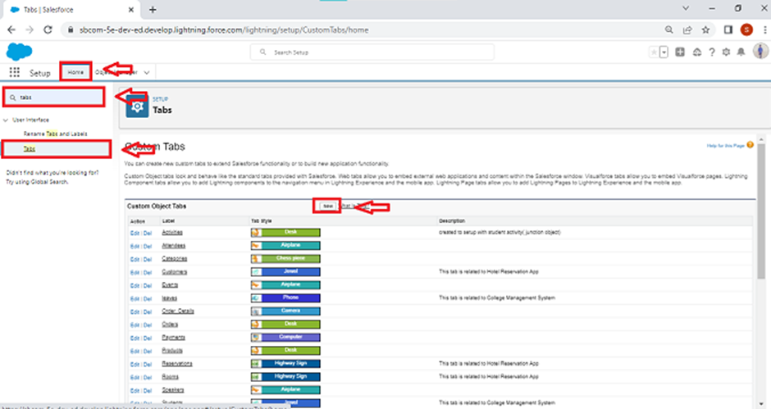

2.Select Object(Fabrication) >> Select the tab style >> Next (Add to profiles page) keep it as default >> Next (Add to Custom App)  uncheck the include tab .

3.Make sure that the Append tab to users' existing personal customizations is checked.

4.Click save

**Creating Remaining Tabs:**

* Now create the Tabs for the remaining Objects, they are “Shed-Work, Pipe lining, Worker”.
* Follow the same steps as mentioned in Activity -1 .

**Create a Lightning App:**

1. Go to setup page >> search “app manager” in quick find >> select “app manager” >> click on New lightning App.

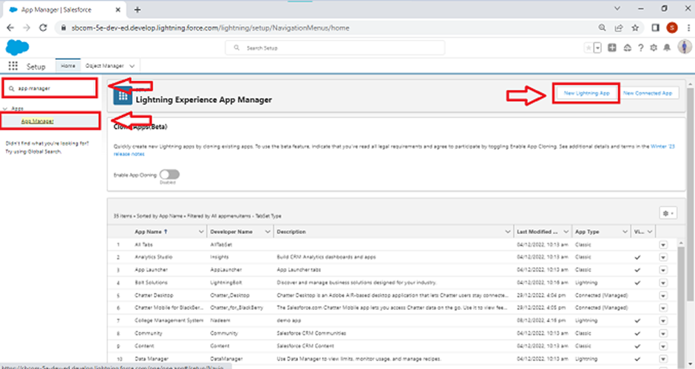

2. Fill the app name in app details and branding as follow  
App Name : Engineering Works  
Developer Name : This will auto populated  
Image : optional (if you want to give any image you can otherwise not mandatory) Primary color hex value : keep this default.

3.Then click Next  >> (App option page)Set Navigation Style as Standard Navigation >> Next.

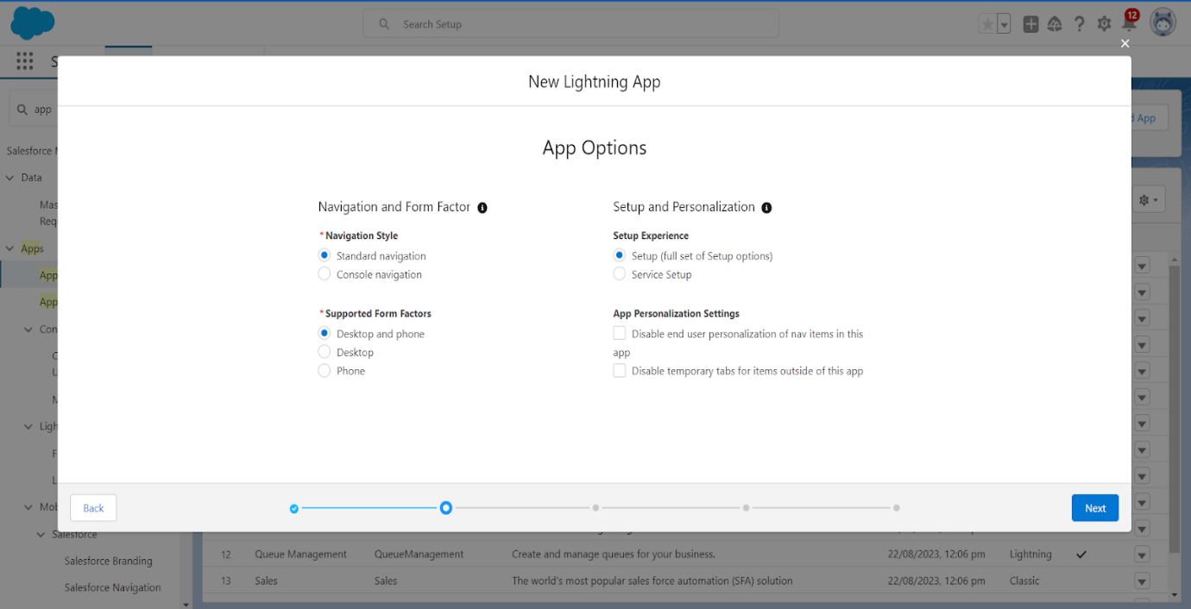

4. (Utility Items) keep it as default >> Next.  
5. To Add Navigation Items:

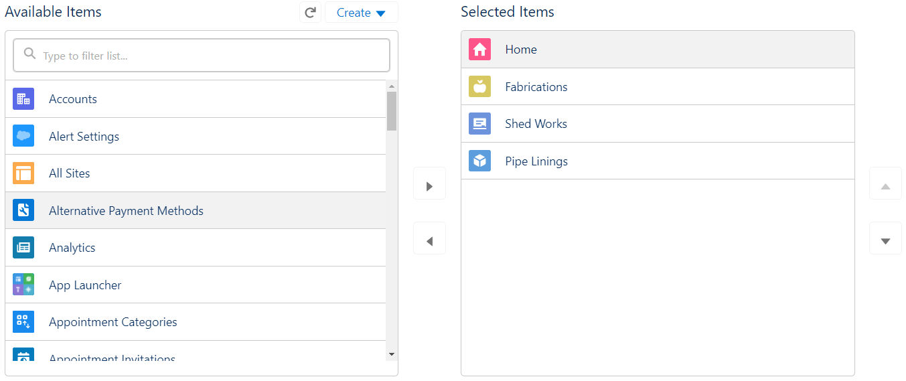

Search for the item in the (Fabrications, Shed Works, Pipe Linings, Workers) from the search bar and move it using the arrow button >> Next >> Next.

6. To Add User Profiles:

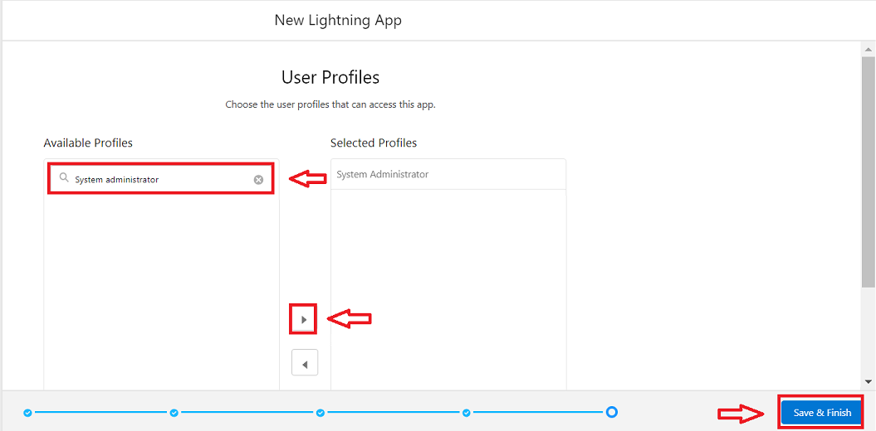

Search profiles (System administrator) in the search bar >> click on the arrow button >> save & finish.

**Creation of fields for the Fabrication object:**

* Go to setup >> click on Object Manager >> type object name(Fabrication) in search bar >> click on the object.

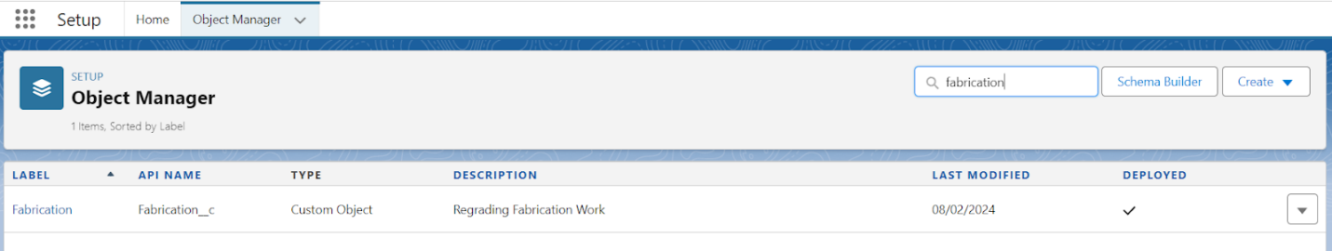

* Now click on “Fields & Relationships” >> New

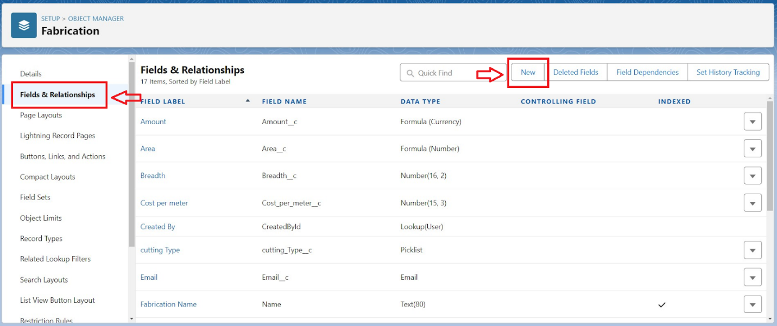

* Select Data Type as a “Text”
* Click on next
* 5. Fill the Above as following:
* Field Label: Name of the Owner
* Field Name : Name_of_the_Owner
* Length : 125
* Required :check box
* Click on Next >> Next >> Save and new.
* To create another fields in an object:
* Go to setup >> click on Object Manager >> type object name(Fabrication) in search bar >> click on the object.
* Now click on “Fields & Relationships” >> New
* Select Data type as a “Text” and Click on Next
* Fill the Above as following:
* Field Label : Name of Company
* Field Name : Name_of_Company
* Click on Next >> Next >> Save and new.
* To create another fields in an object:
* Go to setup >> click on Object Manager >> type object name(Fabrication) in search bar >> click on the object.
* Now click on “Fields & Relationships” >> New
* Select Data type as a “Number” and Click on Next
* Fill the Above as following:
* Field Label: Length
* Field Name : Length
* Length : 16
* Decimal Value : 2
* Required :check box
* Click on Next >> Next >> Save and new.
* To create another fields in an object:
* Go to setup >> click on Object Manager >> type object name(Fabrication) in search bar >> click on the object.
* Now click on “Fields & Relationships” >> New
* Select Data type as a “Number” and Click on Next
* Fill the Above as following:
* Field Label: Breadth
* Field Name : Breadth
* Length : 16
* Decimal Value : 2
* Required :check box
* Click on Next >> Next >> Save and new.
* To create another fields in an object:
* Go to setup >> click on Object Manager >> type object name(Fabrication) in search bar >> click on the object.
* Now click on “Fields & Relationships” >> New
* Select Data type as a “Number” and Click on Next
* Fill the Above as following:
* Field Label: Width
* Field Name : Width
* Length : 16
* Decimal Value : 2
* Required :check box
* Click on Next >> Next >> Save and new.
* To create another fields in an object:
* Go to setup >> click on Object Manager >> type object name(Fabrication) in search bar >> click on the object.
* Now click on “Fields & Relationships” >> New
* Select Data type as a “Formula” and Click on Next
* Fill the Above as following:
* Field Label: Area
* Field Name : Area
* Formula Return Type : Select Number
* Enter Formula : Length__c * Breadth__c * Width__c (Insert this fields using “Insert Field” Option)
* Click on Next >> Next >> Save and new.
* To create another fields in an object:
* Go to setup >> click on Object Manager >> type object name(Fabrication) in search bar >> click on the object.
* Now click on “Fields & Relationships” >> New
* Select Data type as a “Number” and Click on Next
* Fill the Above as following:
* Field Label: Cost per Meter
* Field Name : Cost_per_meter
* Set the Default value to ‘2’
* Click on Next >> Select the read only checkbox
* Click on Next >> Save and new.
* To create another fields in an object:
* Go to setup >> click on Object Manager >> type object name(Fabrication) in search bar >> click on the object.
* Now click on “Fields & Relationships” >> New
* Select Data type as a “Number” and Click on Next
* Fill the Above as following:
* Field Label: Quantity
* Field Name : Quantity
* Length : 16
* Decimal Value : 2
* Required :check box
* Click on Next >> Next >> Save and new.
* To create another fields in an object:
* Go to setup >> click on Object Manager >> type object name(Fabrication) in search bar >> click on the object.
* Now click on “Fields & Relationships” >> New
* Select Data type as a “Formula” and Click on Next
* Fill the Above as following:
* Field Label: Amount
* Field Name : Amount
* Formula Return Type : Select Currency
* Enter Formula : Area__c * Cost_per_meter__c * Quantity_c(Insert this fields using “Insert Field” Option)
* Click on Next >> Next >> Save and new.
* To create another fields in an object:
* Go to setup >> click on Object Manager >> type object name(Fabrication) in search bar >> click on the object.
* Now click on “Fields & Relationships” >> New
* Select Data type as a “Picklist” and Click on Next
* Fill the Above as following:
* Field Label: Material Type
* Field Name : Material_Type
* Values : Select Enter values, with each value separated by a new line
* Enter this values in box :
* Iron
* Aluminum
* Metal
* Wood
* Steel
* Click on Next >> Next >> Save and new.
* To create another fields in an object:
* Go to setup >> click on Object Manager >> type object name(Fabrication) in search bar >> click on the object.
* Now click on “Fields & Relationships” >> New
* Select Data type as a “Currency” and Click on Next
* Fill the Above as following:
* Field Label: Final Price
* Field Name : Final_Price
* Click on Next >> Next >> Save and new.
* To create another fields in an object:
* Go to setup >> click on Object Manager >> type object name(Fabrication) in search bar >> click on the object.
* Now click on “Fields & Relationships” >> New
* Select Data type as a “Email” and Click on Next
* Fill the Above as following:
* Field Label: Email
* Field Name : Email
* Click on Next >> Next >> Save.

**Creation of fields for the Shed-Work object:**

**User:**

* Go to setup >> click on Object Manager >> type object name(Shed-Work) in search bar >> click on the object.
* Now click on “Fields & Relationships” >> New
* Select Data type as a “Text” and Click on Next
* Fill the Above as following:
* Field Label : Name of the Company
* Field Name : gets auto generated
* Click on required check box
* Click on Next >> Next >> Save and new.
* To create another fields in an object:
* Go to setup >> click on Object Manager >> type object name(Shed-Work) in search bar >> click on the object.
* Now click on “Fields & Relationships” >> New
* Select Data type as a “Text” and Click on Next
* Fill the Above as following:
* Field Label : Name of the Owner
* Field Name : Name_of_Owner
* Click on required check box
* Click on Next >> Next >> Save and new.
* To create another fields in an object:
* Go to setup >> click on Object Manager >> type object name(Shed-Work) in search bar >> click on the object.
* Now click on “Fields & Relationships” >> New
* Select Data type as a “Number” and Click on Next
* Fill the Above as following:
* Field Label: Height
* Field Name : Height
* Length : 16
* Decimal Value : 2
* Required :check box
* Click on Next >> Next >> Save and new.
* To create another fields in an object:
* Go to setup >> click on Object Manager >> type object name(Shed-Work) in search bar >> click on the object.
* Now click on “Fields & Relationships” >> New
* Select Data type as a “Number” and Click on Next
* Fill the Above as following:
* Field Label: Breadth
* Field Name : Breadth
* Length : 16
* Decimal Value : 2
* Required :check box
* Click on Next >> Next >> Save and new.
* To create another fields in an object:
* Go to setup >> click on Object Manager >> type object name(Shed-Work) in search bar >> click on the object.
* Now click on “Fields & Relationships” >> New
* Select Data type as a “Number” and Click on Next
* Fill the Above as following:
* Field Label: Width
* Field Name : Width
* Length : 16
* Decimal Value : 2
* Required :check box
* Click on Next >> Next >> Save and new.
* To create another fields in an object:
* Go to setup >>click on Object Manager >> type object name(Shed-Work) in search bar >> click on the object.
* Now click on “Fields & Relationships” >> New
* Select Data type as a “Formula” and Click on Next
* Fill the Above as following:
* Field Label: Area
* Field Name : Area
* Formula Return Type : Select Number
* Enter Formula : Height__c * Breadth__c * Width__c (Insert this fields using “Insert Field” Option)
* To create another fields in an object:
* Go to setup >> click on Object Manager >> type object name(Shed-Work) in search bar >> click on the object.
* Now click on “Fields & Relationships” >> New
* Select Data type as a “Formula” and Click on Next
* Fill the Above as following:
* Field Label: Area Sheet
* Field Name : Area_Sheet
* Formula Return Type : Select Number
* Enter Formula : Height__c * Breadth__c (Insert this fields using “Insert Field” Option)
* To create another fields in an object:
* Go to setup >> click on Object Manager >> type object name(Shed-Work) in search bar >> click on the object.
* Now click on “Fields & Relationships” >> New
* Select Data type as a “Number” and Click on Next
* Fill the Above as following:
* Field Label: Cost per Meter
* Field Name : Cost_per_meter
* Set the Default value to ‘2’
* Click on Next >> Select the read only checkbox
* Click on Next >> Save and new.
* To create another fields in an object:
* Go to setup >> click on Object Manager >> type object name(Shed-Work) in search bar >> click on the object.
* Now click on “Fields & Relationships” >> New
* Select Data type as a “Number” and Click on Next
* Fill the Above as following:
* Field Label: Quantity
* Field Name : Quantity
* Length : 16
* Decimal Value : 2
* Required :check box
* Click on Next >> Next >> Save and new
* To create another fields in an object:
* Go to setup >> click on Object Manager >> type object name(Shed-Work) in search bar >> click on the object.
* Now click on “Fields & Relationships” >> New
* Select Data type as a “Number” and Click on Next
* Fill the Above as following:
* Field Label: Cost per meter sheet
* Field Name : Cost_per_meter_sheet
* Set the Default value to ‘2’
* Click on Next >> Select the read only checkbox
* Click on Next >> Save and new.
* To create another fields in an object:
* Go to setup >> click on Object Manager >> type object name(Shed-Work) in search bar >> click on the object.
* Now click on “Fields & Relationships” >> New
* Select Data type as a “Formula” and Click on Next
* Fill the Above as following:
* Field Label: Amount
* Field Name : Amount
* Formula Return Type : Select Currency
* Enter Formula : Area__c * Cost_per_meter__c * Quantity_c(Insert this fields using “Insert Field” Option)
* Click on Next >> Next >> Save and new.
* To create another fields in an object:
* Go to setup >> click on Object Manager >> type object name(Shed-Work) in search bar >> click on the object.
* Now click on “Fields & Relationships” >> New
* Select Data type as a “Formula” and Click on Next
* Fill the Above as following:
* Field Label: Amount Sheet
* Field Name : Amount_Sheet
* Formula Return Type : Select Currency
* Enter Formula : Cost_per_meter_sheet__c * Area_Sheet__c * Quantity_c(Insert this fields using “Insert Field” Option)
* Click on Next >> Next >> Save and new.
* To create another fields in an object:
* Go to setup >> click on Object Manager >> type object name(Shed-Work) in search bar >> click on the object.
* Now click on “Fields & Relationships” >> New
* Select Data type as a “Picklist” and Click on Next
* Fill the Above as following:
* Field Label: Material Type
* Field Name : Material_Type
* Values : Select Enter values, with each value separated by a new line
* Enter this values in box :
* Iron
* Metal
* Steel
* Click on Next >> Next >> Save and new.
* To create another fields in an object:
* Go to setup >> click on Object Manager >> type object name(Shed-Work) in search bar >> click on the object.
* Now click on “Fields & Relationships” >> New
* Select Data type as a “Picklist” and Click on Next
* Fill the Above as following:
* Field Label: Material Type Sheet
* Field Name : Material_Type_Sheet
* Values : Select Enter values, with each value separated by a new line
* Enter this values in box :
* Plastic
* Metal
* Rubber
* Click on Next >> Next >> Save and new.
* To create another fields in an object:
* Go to setup >> click on Object Manager >> type object name(Shed-Work) in search bar >> click on the object.
* Now click on “Fields & Relationships” >> New
* Select Data type as a “Currency” and Click on Next
* Fill the Above as following:
* Field Label: Final Price
* Field Name : Final_Price
* Click on Next >> Next >> Save and new.
* To create another fields in an object:
* Go to setup >> click on Object Manager >> type object name(Shed-Work) in search bar >> click on the object.
* Now click on “Fields & Relationships” >> New
* Select Data type as a “Email” and Click on Next
* Fill the Above as following:
* Field Label: Email
* Field Name : Email
* Click on Next >> Next >> Save.

**Like wise create a field for each:**

* Shed-Workers
* PipeLining
* Worker Object
* Lookup Field

**To create a Page Layout in Fabrication Object for Drilling:**

Go to the setup page >> click on object manager >> From drop down click edit for Fabrication object.

Click on the Page Layouts >> click New.

Enter details as

Page Layout Name : Drilling Page Layout

Click on Save

Drag and Arrange the field as shown below

Click Save.

**Create a Record Triggered Flow:**

**Configure the Start Element:**

* From Setup, enter Flows in the Quick Find box, then select Flows.
* Click New Flow.
* Select Record-Triggered Flow.
* Click Create. The Configure Start window opens.
* For Object, select Appointment.
* For Trigger the Flow When, select A record is created.

**Add an Action Element:**

* Add an Action element after the Start Element and Select the Submit for approval action, label it as “Approval SubFlow”.
* Set the RecordId to “{!$Record.Id}”.
* Save the Flow, label it as "EduConsultPro Approval Flow and Click on Activate.

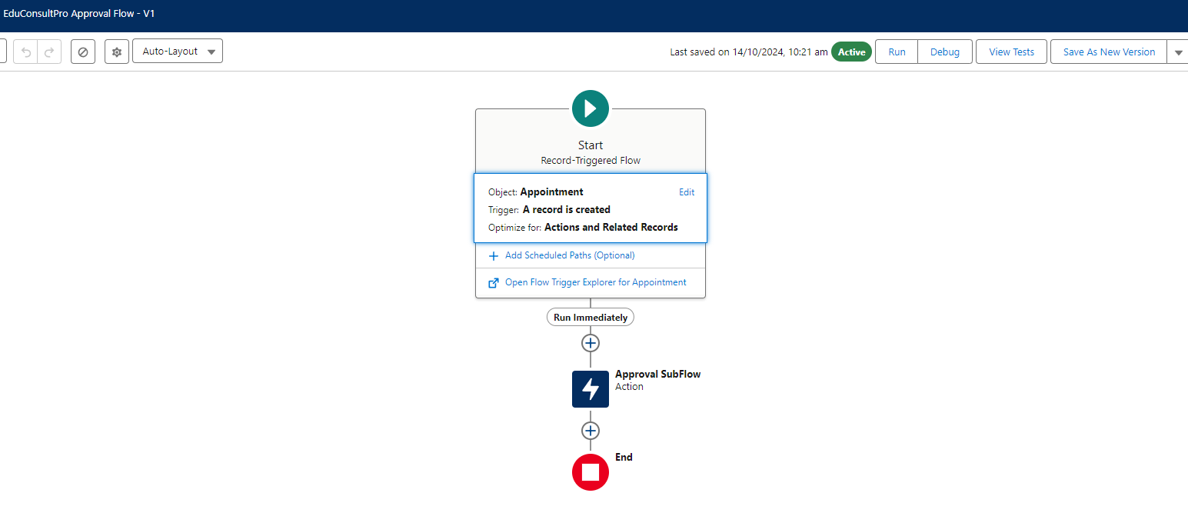

**Likewise Create pageflow for :**

* Drilling
* Cutting
* Folding

**create a Record Types in Fabrication Object:**

* Go to the setup page >> click on object manager >> From drop down click edit for Fabrication object.
* Click on the Record Types >> click New.

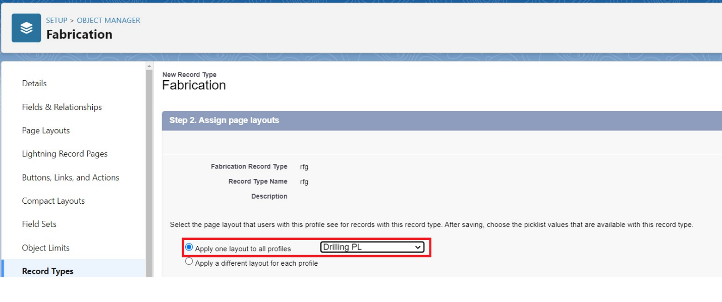

* Enter the details : For Record Types
* Existing Record Types : Master
* Record Type Label : Drilling
* Record Type Name : Drilling
* Active : Tick checkbox
* Click on Next
* In Assign Page Layout
* Apply one layout to all profiles : Select Drilling Page Layout
* Click on Save
* Similarly, Create the Record Types on Welding Page Layout, Cutting Page Layout and Folding Page Layout

**create a validation rule to an Fabrication Object:**

Go to the setup page >> click on object manager >> From drop down click edit for Fabrication object.

Click on the validation rule >> click New.

3. Enter the Rule name as “Rule_for_fabrication”.

4. Insert the Error Condition Formula as :

OR( Length__c == 0, Breadth__c == 0, Width__c ==0, Quantity == 0)

5. Enter the Error Message as “Length, Breadth, Width and Quantity Values should not be zero”, select the Error location as Top of Page and click Save.

Create the Validation Rule for Shed-Work and Pipe Lining Object Similarly by following the Activity 1 Steps.

**Upload Logo into Salesforce:**

Go to the setup page >> In quick find box search for Salesforce Branding >> Click on Edit.

In Loading Page Logo >> Choose File >> Select the image and click open >> Click on Save.

**Creation of Letterhead for Email purpose:**

* **Go to the setup page >> In quick find box search for Classic Letterheads >> Click on New Letterhead.**
* **Check Available for use box.**
* **Letterhead Label : Letterhead for Email Purpose**
* **Letterhead Unique Name : Auto-populated**
* **Click on Save >> Now click on Letterhead for Email Purpose then Edit Letterhead.**
* 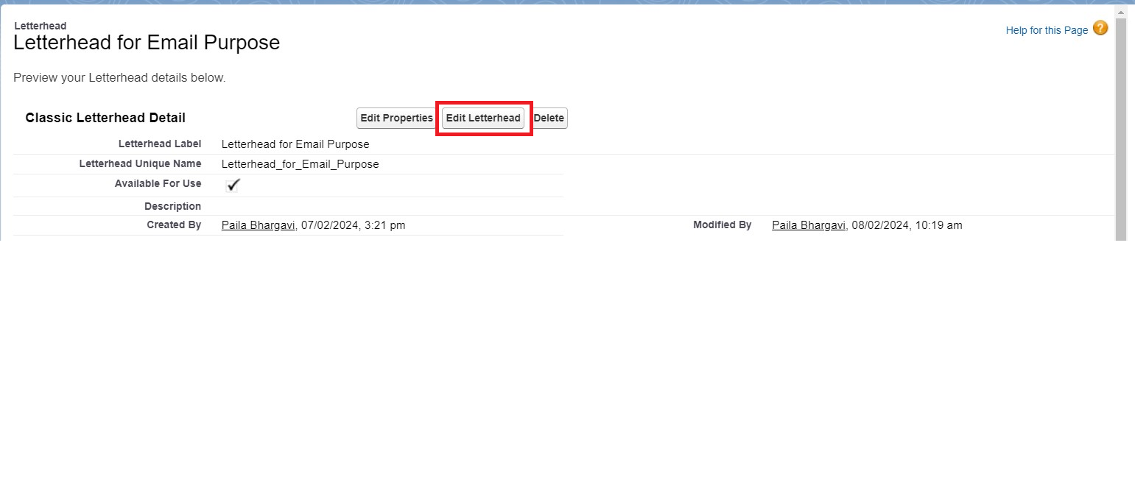**Click on select logo >> Now select the logo and click save.**

**Create Email Template.**

**To create Email Template:**

* Go to setup in quick find box enter email template >> click on classic Email Template.
* Click on >> New Email Template===>HTML (using Classic Letterhead)
* Folder : Unfiled public Classic Email templates
* Click on available for use
* Email Template Name is “Bill Template”
* Template Unique Name : Auto populated
* Subject : “Fabrication Template”
* Email body :
* Hello {!Fabrication__c.Name_of_the_Owner__c}{!Shed_Work__c.Name_of_the_Owner__c}{!Pipe_Lining__c.Name_of_Owner__c} ,
* I hope everything is going well in {!Fabrication__c.Name_of_Company__c} {!Shed_Work__c.Name_of_Company__c}{!Pipe_Lining__c.Name_of_Company__c} Company. I have been attached the required items for the work to be done. Please verify them.
* length = {!Fabrication__c.Length__c}{!Shed_Work__c.Height__c}{!Pipe_Lining__c.Height__c}, breadth = {!Fabrication__c.Length__c}{!Shed_Work__c.Breadth__c}, width = {!Fabrication__c.Width__c}{!Shed_Work__c.Width__c}{!Pipe_Lining__c.Width__c}, area = {!Fabrication__c.Area__c}{!Shed_Work__c.Area__c}{!Pipe_Lining__c.Area__c}, The Final Price = {!Fabrication__c.price__c}{!Shed_Work__c.Price__c}{!Pipe_Lining__c.Price__c}.
* Thanks & Regards,
* Engineering Works.
* Save
* Similarly Create an Email Template for Shed-work Object and Pipe Lining Object.

**Create Email Alert:**

* Go to setup in quick find box enter email Alert >> New Email Alert
* Description : Email Alert for Fabrication Object
* Unique Name : Auto-Populated
* Object : Fabrication
* Email Template : select the template that is for fabrication Object
* Recipients : User: Integration User, User : System Administrator, user : Security User
* Click Save
* Similarly create for Pipe-Lining and Shed-Work objects

**Create Flow to calculate Final Price on Fabrication Object based on Material Type:**

1. Go to setup >> type Flow in quick find box >> Click on the Flow and Select the New Flow.
2. Select the record Triggered flow.Click on create.

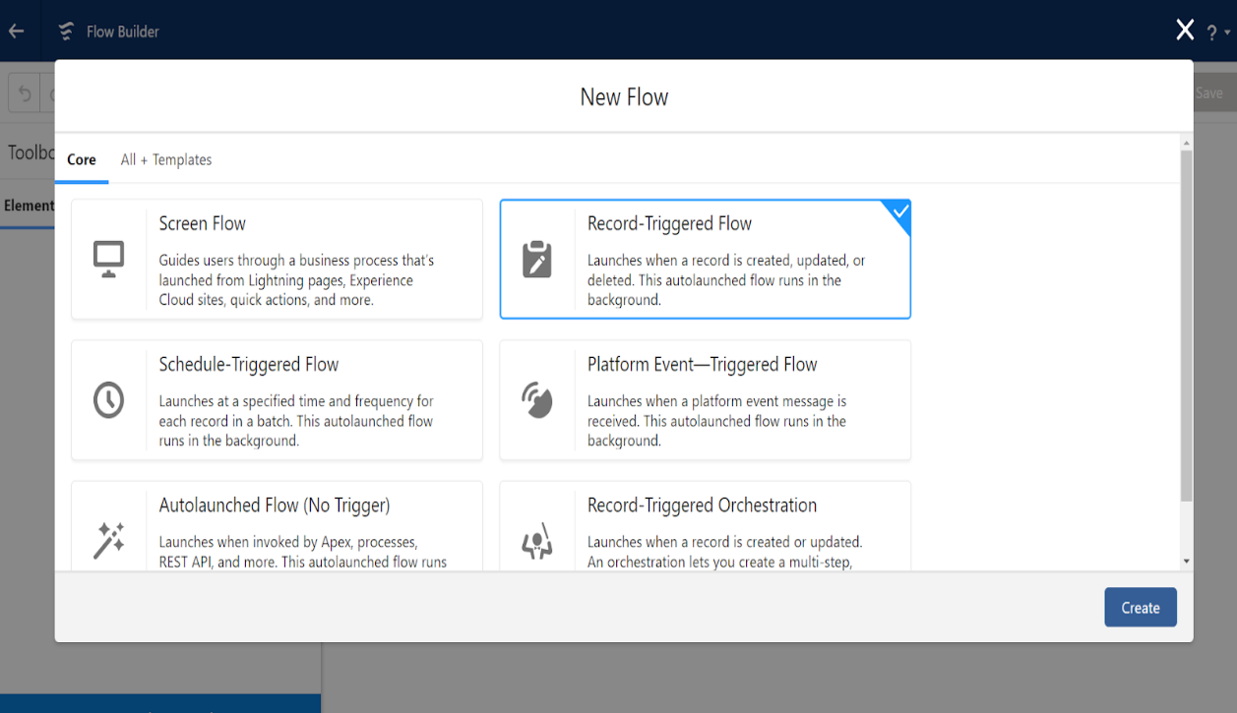

1. Under Object select ”Fabrication”. Click on  A record is created or updated.

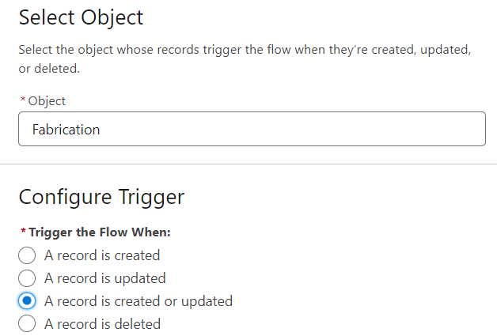

1. Set Entry Conditions : None
2. Select Actions and Related Records

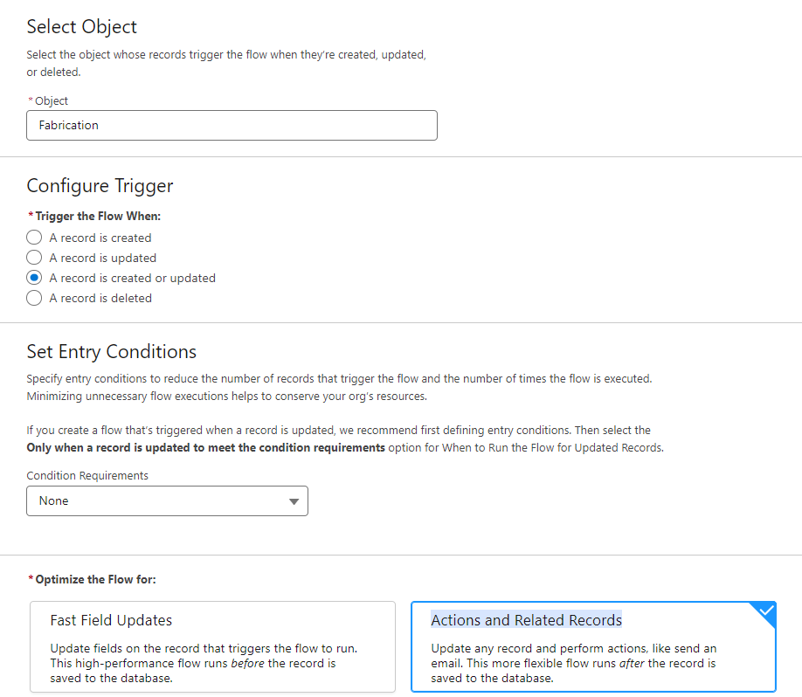

1. Under record trigger flow click on “+” icon and select Send Email Alert.

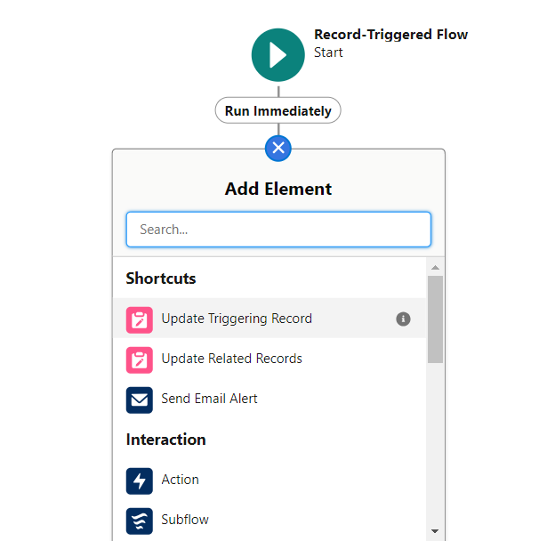

1. In New Action Select Fabrication Template.

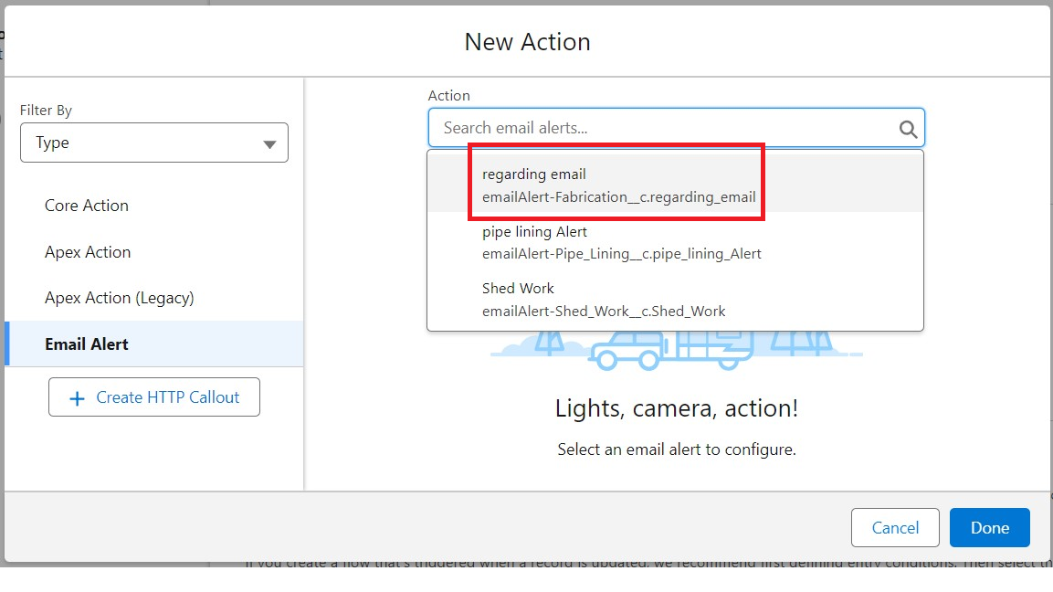

1. Label : Mail
2. API Name : Mail
3. Record ID : {!$Record.Id}

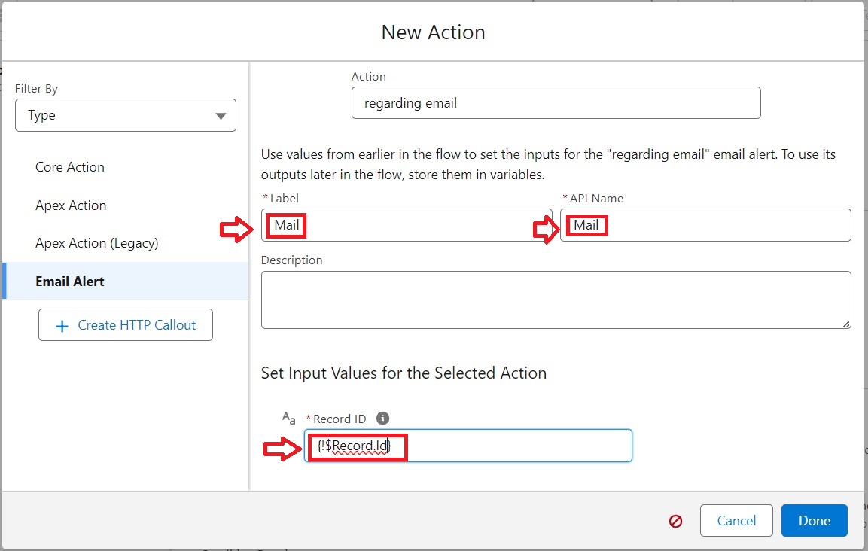

1. Click Done.
2. Under record trigger flow click on “+” icon and select Decision

For New Decision :

* Label : Material
* Api Name : Material

For Outcome Details :

* Label : Iron Material
* Outcome API Name : Iron_Material
* Condition Requirements to Execute Outcome : Condition Requirements to Execute Outcome
* Resource : {!$Record.Material_Type__c}
* Operator : Equals
* Value : Iron

In the Outcome Order click ‘+’ Icon and create another four outcomes for Aluminum, Metal, Wood, Steel(for each outcome keep the respective value)

* For Aluminum >> Value : Aluminum
* For Metal >> Value : Metal
* For Wood >> Value : Wood
* For Steel >> Value : Steel

The Outcome Details will be seen like below :

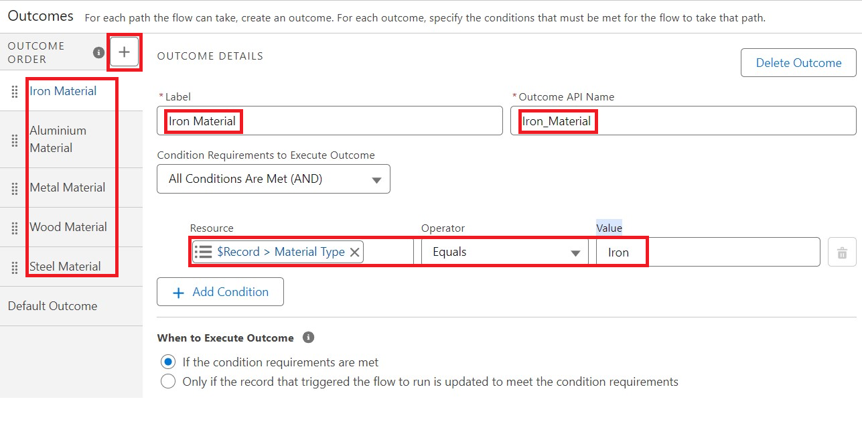

1. Under Iron Material click on “+” icon and select Update Related Record.

* Label : For Iron
* API Name : For_Iron
* How to Find Records to Update and Set Their Value : Select Use the fabrication record that triggered the flow
* Set Filter Conditions : None—Always Update Record
* Set Field Values for the Fabrication Record

Field : Final_price__c

* For Value click on New resource

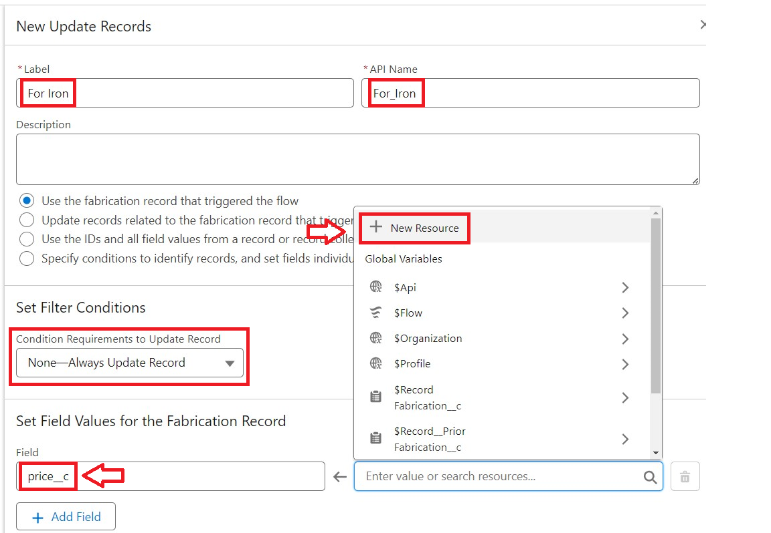

* In Resource Type : Select Formula
* API Name : IronCost

Data Type : Number

Decimal Places : 2

Formula : {!$Record.Amount__c} * 2

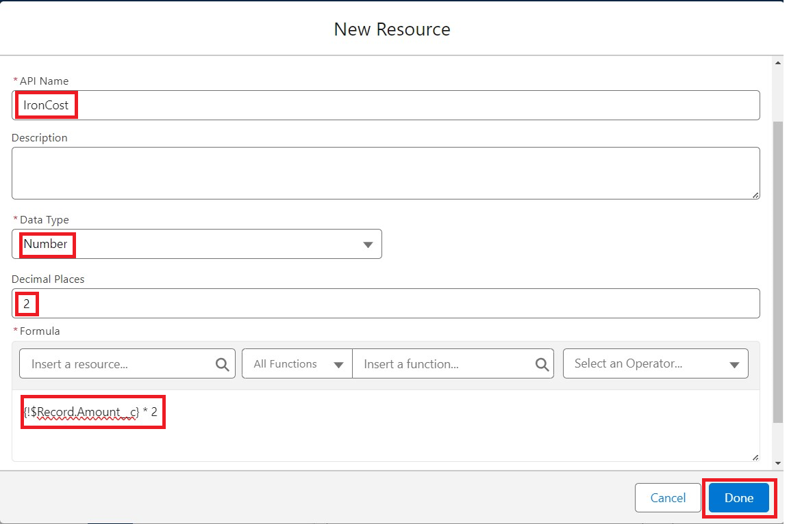

* Click Done

1. After clicking Done, it would look like

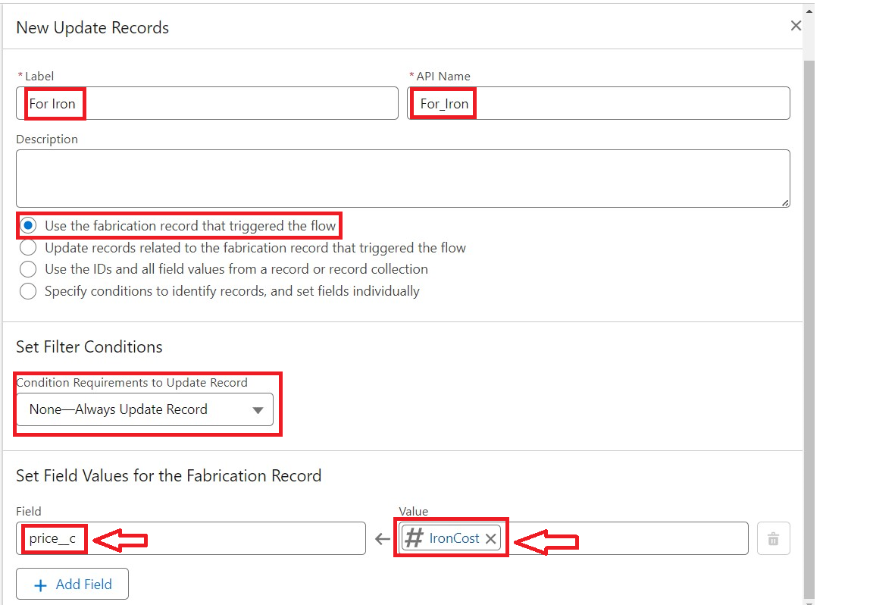

1. Under Aluminum Material click on “+” icon and select Update Related Record.

* Label : For Aluminum
* API Name : For_Aluminum
* How to Find Records to Update and Set Their Value : Select Use the fabrication record that triggered the flow
* Set Filter Conditions : None—Always Update Record
* Set Field Values for the Fabrication Record

Field : Final_price__c

* For Value click on New resource
* In Resource Type : Select Formula
* API Name : AluminumCost

Data Type : Number

Decimal Places : 2

Formula : {!$Record.Amount__c} * 1.8

* Click Done

1. Under Metal Material click on “+” icon and select Update Related Record.

* Label : For Metal
* API Name : For_Metal
* How to Find Records to Update and Set Their Value : Select Use the fabrication record that triggered the flow
* Set Filter Conditions : None—Always Update Record
* Set Field Values for the Fabrication Record

Field : Final_price__c

* For Value click on New resource
* In Resource Type : Select Formula
* API Name : MetalCost

Data Type : Number

Decimal Places : 2

Formula : {!$Record.Amount__c} * 1.6

* Click Done

1. Under WoodMaterial click on “+” icon and select Update Related Record.

* Label : For Wood
* API Name : For_Wood
* How to Find Records to Update and Set Their Value : Select Use the fabrication record that triggered the flow
* Set Filter Conditions : None—Always Update Record
* Set Field Values for the Fabrication Record

Field : Final_price__c

* For Value click on New resource
* In Resource Type : Select Formula
* API Name : WoodCost

Data Type : Number

Decimal Places : 2

Formula : {!$Record.Amount__c} * 1.4

* Click Done

1. Under Steel Material click on “+” icon and select Update Related Record.

* Label : For Steel
* API Name : For_Steel
* How to Find Records to Update and Set Their Value : Select Use the fabrication record that triggered the flow
* Set Filter Conditions : None—Always Update Record
* Set Field Values for the Fabrication Record

Field : Final_price__c

* For Value click on New resource
* In Resource Type : Select Formula
* API Name : SteelCost

Data Type : Number

Decimal Places : 2

Formula : {!$Record.Amount__c} * 1.2

* Click Done

1. Click on Save

* Flow Label : Fabrication Flow
* Flow API Name : Fabrication_Flow
* Click Save and then active

1. The Flow will like this :

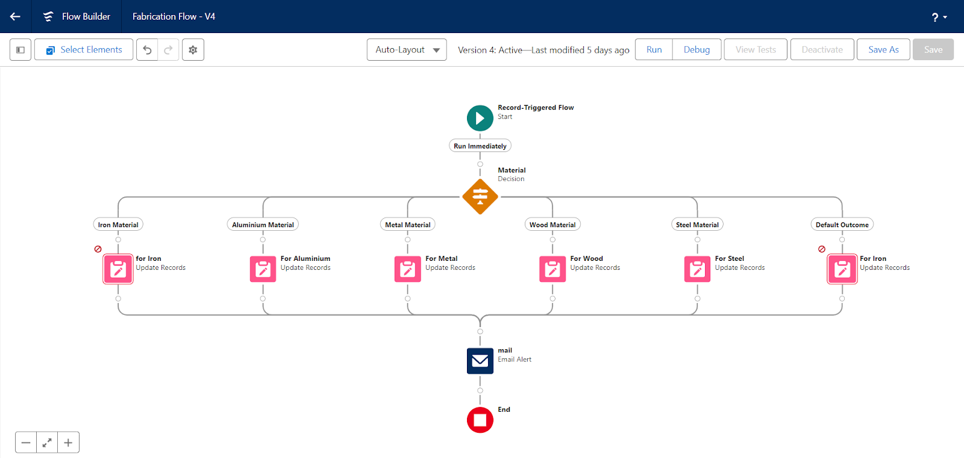

**Likewise create flow for:**

* **Shed-works**
* **Pipe-Lining**

**Key Scenarios Addressed by Salesforce in the Implementation Project**

**Managing Client and Project Information:**

**Scenario: Engineering firms need a reliable system to store client data, including contact information, company details, and past projects, ensuring all information is accessible in one place.**

**Salesforce Solution: Salesforce’s Account and Contact Management allows seamless storage and access to client details, while Opportunities help manage each engineering project. Custom objects can also capture specific project details (e.g., materials, measurements, and pricing).**

**Conclusion**

The CRM application for Engineering Works has been successfully developed and implemented to meet the specific needs of the engineering industry. The application enables seamless management of client information, project workflows, and resource allocation, providing a centralized platform that enhances efficiency and project oversight. By automating calculations, tracking engineering tasks, and delivering transparent client communication, this solution empowers the business to improve service quality and build stronger client relationships.

**Summary of Achievements:**

Successfully created a tailored CRM application to manage engineering projects and streamline workflows.

Enhanced operational efficiency through automated processes for task assignments, material calculations, and client updates.

Improved resource allocation and worker management, optimizing project timelines and labor utilization.

Enabled real-time data accuracy and insightful reporting for better decision-making.

Increased client satisfaction with transparent project tracking and a dedicated client portal.

Established a scalable system capable of supporting future business growth and expanded project capacity.